 



# Database Programming with SQL

* 1. : PRIMARY KEY, FOREIGN KEY, and CHECK Constraints

# Practice Activities

## Objectives

* + - Define and give an example of PRIMARY KEY, FOREIGN KEY, and CHECK constraints
    - Explain the purpose of defining PRIMARY KEY, FOREIGN KEY, and CHECK constraints on a table
    - Demonstrate the creation of constraints at the column level and table level in a CREATE TABLE statement
    - Evaluate a business problem requiring the addition of a PRIMARY KEY and FOREIGN KEY constraint and write the code to execute the change

## Vocabulary

Identify the vocabulary word for each definition below.

|  |  |
| --- | --- |
| **ON DELETE CASCADE** | Allows a foreign key row that is referenced to a primary key row to be deleted |
| **Check Constraint** | Explicitly defines a condition that must be met |
| **PRIMARY KEY** | A column or set of columns that uniquely identifies each row in a table |
| **NOT NULL** | Constraint ensures that the column contains no null values |
| **ON DELETE SET NULL** | Allows a child row to remain in a table with null values when a parent record has been deleted |
| **FOREIGN KEY Constraint** | Establishes a relationship between the foreign key column and a primary key or unique key in the same table or a different table |

## Try It / Solve It

1. What is the purpose of a
   1. PRIMARY KEY

Уникальный идентификатор каждой строки таблицы

* 1. FOREIGN KEY

Свзяывает первичный ключ со столбцом дочерней таблицы

* 1. CHECK CONSTRAINT

Проверка существования ограничения

1. Using the column information for the animals table below, name constraints where applicable at the table level, otherwise name them at the column level. Define the primary key (animal_id). The license_tag_number must be unique. The admit_date and vaccination_date columns cannot contain null values.

animal_id NUMBER(6) PRIMARY KEY

name VARCHAR2(25)

license_tag_number NUMBER(10) UNIQUE

admit_date DATE NOT NULL

adoption_id NUMBER(5),

vaccination_date DATE – NOT NULL

1. Create the animals table. Write the syntax you will use to create the table.

CREATE TABLE animals

( animal_id NUMBER(6,0) CONSTRAINT anl_anl_id_pk PRIMARY KEY ,

name VARCHAR2(25),

license_tag_number NUMBER(10,0) CONSTRAINT anl_l_tag_num_uk UNIQUE,

admit_date DATE CONSTRAINT anl_adt_dat_nn NOT NULL ENABLE,

adoption_id NUMBER(5,0),

vaccination_date DATE CONSTRAINT anl_vcc_dat_nn NOT NULL ENABLE

);

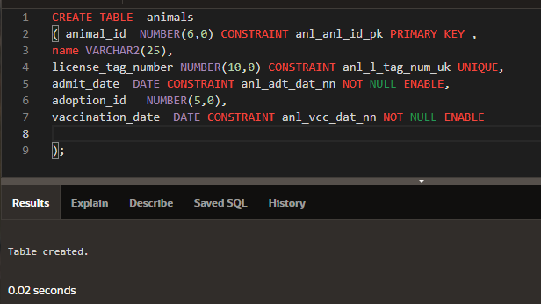

SELECT *

FROM user_constraints

WHERE LOWER(table_name) = 'animals';

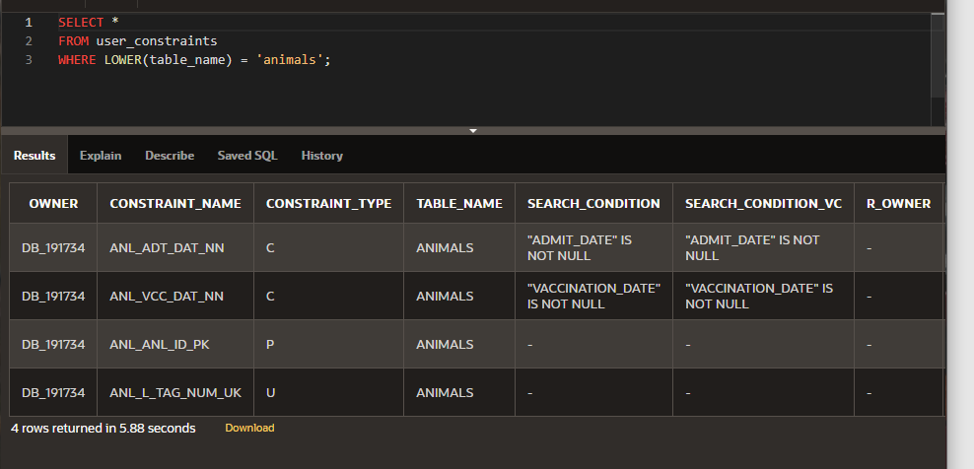

1. Enter one row into the table. Execute a SELECT * statement to verify your input. Refer to the graphic below for input.

|  |  |  |  |  |  |
| --- | --- | --- | --- | --- | --- |
| ANIMAL_ ID | NAME | LICENSE_TAG_ NUMBER | ADMIT_DATE | ADOPTION_ ID | VACCINATION_ DATE |
| 101 | Spot | 35540 | 10-Oct-2004 | 205 | 12-Oct-2004 |

INSERT INTO animals (animal_id, name, license_tag_number, admit_date, adoption_id, vaccination_date)

VALUES( 101, 'Spot', 35540, TO_DATE('10-Oct-2004', 'DD-Mon-YYYY'), 205, TO_DATE('12-Oct-2004', 'DD-Mon-YYYY'));

SELECT * FROM animals;

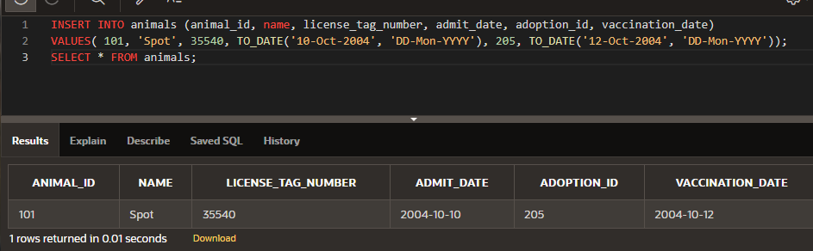

1. Write the syntax to create a foreign key (adoption_id) in the animals table that has a corresponding primary- key reference in the adoptions table. Show both the column-level and table-level syntax. Note that because you have not actually created an adoptions table, no adoption_id primary key exists, so the foreign key cannot be added to the animals table.

SELECT *

FROM user_constraints

WHERE LOWER(table_name) = 'animals' AND constraint_type = 'R';

ALTER TABLE animals ADD CONSTRAINT anl_adopt_id_fk FOREIGN KEY (adoption_id)

REFERENCES adoptions(id) ENABLE;

1. What is the effect of setting the foreign key in the ANIMAL table as:
   1. ON DELETE CASCADE

**ALTER TABLE  animals**

**ADD CONSTRAINT anl_adopt_id_fk  FOREIGN KEY (adoption_id)**

**REFERENCES  adoptions(id) ON DELETE CASCADE  ENABLE ;**

**ALTER TABLE  animals**

**ADD CONSTRAINT anl_adopt_id_fk  FOREIGN KEY (adoption_id)**

**REFERENCES  adoptions (id) ENABLE ;**

* 1. ON DELETE SET NULL

**ALTER TABLE  animals**

**ADD CONSTRAINT anl_adopt_id_fk  FOREIGN KEY (adoption_id)**

**REFERENCES  adoptions(id) ON DELETE SET NULL  ENABLE ;**

1. What are the restrictions on defining a CHECK constraint?

Проверка ограничений НЕ может быть определена в SQL View.

Проверка ограничений, определенная в таблице, должна ссылаться только на столбцы в этой таблице. Она не может ссылаться на столбцы в других таблицах.

Проверка ограничений НЕ может подключать SQL-подзапрос.

Проверка ограничений может быть определена в SQL CREATE TABLE или SQL ALTER TABLE.

Copyright © 2020, Oracle and/or its affiliates. All rights reserved. Oracle and Java are registered trademarks of Oracle and/or its affiliates. Other names may be trademarks of their respective owners.